**Project Planning Phase**

**SPRINT DELIVERY - 1**

|  |  |
| --- | --- |
| Team ID | PNT2022TMID24776 |
| Project Name | Project – Smart Farmer-IoT based Smart Farming Application |
| Maximum Marks | 8 Marks |

**INTRODUCTION**

The main aim of this project is to help farmers automate their farms by providing them with a Web App through which they can monitor the parameters of the field like Temperature, soil moisture, humidity and etc and control the equipment like water motor and other devices remotely via internet without their actual presence in the field.

**PROBLEM STATEMENT**

IoT technology has created a revolution in our modern world, enhancing every field in every man's life and upgrading everything as smart by making smart decisions and implementing work in a better way. For the development of agriculture, IoT technology brings day to day devices that are used in agricultural production by making them cost effective and reducing waste. The aim of this survey is to propose an IoT based project that assists the farmers by extracting the efficient environment monitoring factors in agriculture that is essential part of the overall yield and the quality of the product. Since the global population has been predicted to exceed 9.6 billion by 2050, which poses a big problem for the agricultural fields. In spite of overcoming the challenges such as extreme weather conditions, rising climate change and the farming environmental impact, the demand for food is very much increased.

PROPOSED SOLUTION

|  |  |  |
| --- | --- | --- |
| **S. No.** | **Parameter** | **Description** |
| 1. | Problem Statement (Problem to be solved) | To incorporate the process of working and also elevate the smart farming using IOT enabled smart Farming technique since the traditional Farming technique I very  complex one. |
| 2. | Idea / Solution description | To automate irrigation in accordance to the amount of moisture present in soil |
| 3. | Novelty / Uniqueness | Automation of irrigation to amount of moisture |
| 4. | Social Impact / Customer Satisfaction | The problems faced by the farmers in the  process of irrigation gets solved and this full fills and saves their crops from over irrigation |
| 5. | Business Model (Revenue Model) | The process of fulfilling this process brings revolution in drip irrigation systems also makes a revolutionary change in market |
| 6. | Scalability of the Solution | The design scale of solution has been planned in a compact manner |

TECHNICAL ARCHITECTURE

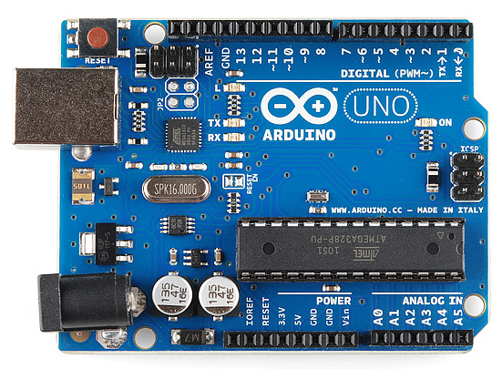 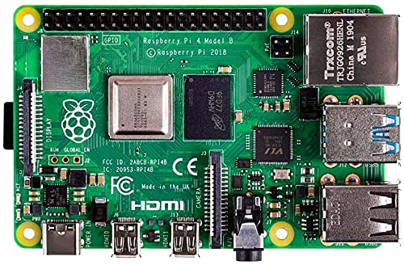

**ARDIUNO-UNO RASPBERRY-PI**

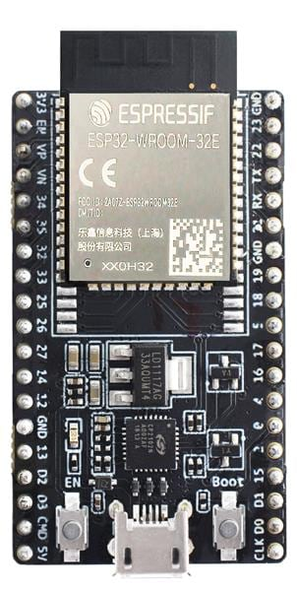

**ESP- 32 KIT**



**IBM WATSON PLATFORM**





**USER INTERRFACE**





**USER MOBILE APP**

**SMART AUTOMATION USING ARDUINO:**

**CODE:**

int pinled =12;

int pinsensor =2;

int buzzerpin =13;

int pirsensor =1;

int temperaturesensor =A0;

void setup()

{

Serial.begin(960);

pinMode(temperaturesensor,INPUT);

pinMode(pinled,OUTPUT);

pinMode(buzzerpin,OUTPUT);

pinMode(pinsensor,INPUT);

}

void loop()

{

pirsensor =digitalRead(pinsensor);

if(pirsensor ==HIGH)

{

digitalWrite(pinled,HIGH);

tone(buzzerpin,1000,500);

Serial.println("motion is detected!!!!!!!!!!!! ");

delay(1000);

Serial.println("*******");

}

else

digitalWrite(pinled,LOW);

delay(500);

double a = analogRead(A0);

double ca = (((a/1024)*5)-0.5)*100;

Serial.println("the temperature is : ");

Serial.println(ca);

}

**SIMULATION DIAGRAM:**

